**SQL Case Study: Analyzing Foodpanda Data for a Partner Restaurant**

**Introduction**

Foodpanda is a popular food delivery platform that connects customers with various restaurants. In this case study, we will analyze data from Foodpanda partner restaurant optimize its operations and improve its performance. The restaurant, referred to as "Partner Restaurant," has been using Foodpanda but needs assistance in utilizing the data available on the platform effectively.

**Objective:**

To analyze Foodpanda data for the Partner Restaurant and provide insights to enhance its operations and overall performance.

**Key Questions & Reason for Analysis:**

These key questions provide insights into various aspects of the Partner Restaurant's operations, customer satisfaction, revenue generation, and compering positioning. By addressing these questions and leveraging the resulting insights, the Partner Restaurant can make informed decisions, enhance its opera drive overall performance improvements.

**Which menu items are the most popular among customers based on the number of orders? Tables: Orders, Menu**

**Analysis Reason:** This analysis helps identify the popular menu items that have a high demand among customers. By understanding the most popular items, the Partner Restaurant can optimize its inventory, ensure the availability of popular dishes, and focus on improving the quality and presentation of items.

**What are the peak hours or days when the Partner Restaurant receives the most orders? Tables: Orders, Restaurants**

**Analysis Reason:** Analyzing the peak hours or days helps the Partner Restaurant effectively manage its resources, including staffing and inventory. By the busiest periods, they can allocate sufficient staff, streamline operations, and ensure timely order fulfillment to provide a positive customer experience.

**Are there specific customer preferences or patterns observed in the order history, such as frequently ordered menu items? Tables: Orders, Menu**

**Analysis Reason:** By analyzing customer preferences and patterns in the order history, the Partner Restaurant can gain insights into popular menu item customer preferences. This information can be used to tailor the menu, introduce new dishes, and create targeted marketing campaigns to cater to customer preferences and drive repeat orders.

**How the revenue generated through Foodpanda does vary over time, and are there any seasonal or trend-related patterns? Tables: Orders, Menu**

**Analysis Reason:** Tracking revenue variations over time helps the Partner Restaurant identify seasonal or trend-related patterns. This analysis allows the promotional offers, adjust pricing strategies, and allocate resources efficiently during high-demand periods, ultimately maximizing revenue generation.

**What is the average delivery time for orders, and are there any delays or areas for improvement? Tables: Orders, Restaurants**

**Analysis Reason:** Analyzing delivery times helps the Partner Restaurant assess its efficiency in order processing and delivery. By identifying any delays for improvement, they can streamline their operations, optimize the delivery process, and enhance overall customer satisfaction.

**How do menu item prices and discounts affect customer ordering behavior and revenue generation?**

**Tables: Menu, Orders**

**Analysis Reason:** Analyzing the impact of menu item prices and discounts on customer ordering behavior helps the Partner Restaurant determine opting strategies. This analysis enables them to understand how pricing influences customer choices, revenue generation, and profitability.

**What are the common customer complaints or compliments received by the Partner Restaurant? Tables: Orders, Restaurants**

**Analysis Reason:** Monitoring customer feedback helps the Partner Restaurant identify areas for improvement and address any recurring issues. By add complaints and leveraging positive feedback, they can enhance customer satisfaction, improve service quality, and build a positive brand reputation.

**What is the overall customer satisfaction level for the Partner Restaurant based on ratings and reviews? Tables: Orders, Restaurants**

**Analysis Reason:** Evaluating customer satisfaction based on ratings and reviews helps the Partner Restaurant gauge the quality of its offerings and service analysis provides valuable insights into areas of improvement and enables them to take necessary actions to enhance overall customer satisfaction.

**Are there any issues or challenges related to payments or order cancellations?**

**Tables: Orders, Restaurants**

**Analysis Reason:** Analyzing payment-related issues and order cancellations helps the Partner Restaurant identify and address any challenges in the ordering process. By streamlining payment processes and addressing issues promptly, they can improve the overall customer experience and minimize potential loss.

**How does the Partner Restaurant's performance compare to its competitors in terms of ratings, delivery time, and customer satisfaction? Tables: Orders, Restaurants**

**Analysis Reason:** Benchmarking the Partner Restaurant's performance against competitors provides insights into its competitive positioning. By evaluate ratings, delivery times, and customer satisfaction, they can identify areas for improvement and develop strategies to differentiate themselves, attract more customers, and deliver superior experiences.

**Data Schema:**

Following are the data schema for the Foodpanda case study, including the tables and their columns, along with three sample records for each table:

**Orders Table:**

order_id

customer_id

menu_item_id

order_timestamp

delivery_partner_id

order status

delivery_timestamp

complaint_or_compliment_message

Payment_or_cancellation_issue

restaurant_id

**Sample Data:**

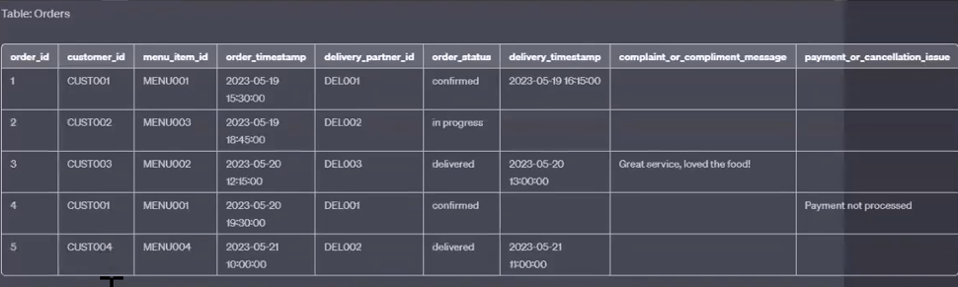

**Menu Table:**

menu_item_id

item_name

description

price

discount_percentage

category

**Sample Data:**

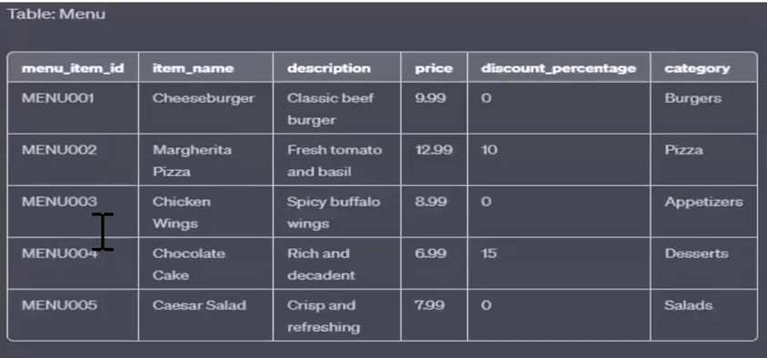

..

**Restaurant Table:**

restaurant_id

restaurant_name

address

city

state

average_rating

**Sample Data:**

